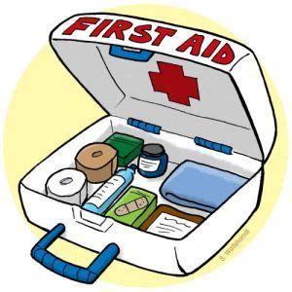Micro Family Youth Soccer League (MFYSL)
MEDICAL RELEASE FORM

I hereby give my permission for any and all necessary medical attention to be administered to my children in the event of an accident, injury, sickness, etc.

Name(s) of Children: __________________________________________________________________________
__________________________________________________________________________
__________________________________________________________________________

I allow this under the direction of the person(s) listed below until I can be contacted. This release is effective for one year from the date written below. I also assume responsibility to pay for any such treatment.

Address:__________________________________________________________________
Cell:________________________ Text? Y/N Home Phone:________________________
Office Phone: ______________________

Insurance Company:________________________________________________________
Policy/ID Number:__________________________________________________________
Group Number:____________________________________________________________
Child’s Physician:__________________________________________________________
Physician’s Phone:_________________________________________________________
Known Allergies:___________________________________________________________

Any of the following people may act on my behalf if I cannot be reached:

1. A league representative where my child is playing
2. _______________________________________
3._______________________________________

Print Name of Parent or Guardian: ________________________________________
Signature and Date: ___________________________________________________

